**Digital Portfolio**

STUDENT NAME: Muralidharan R

REGISTER NO AND NMID:2426J0264/

82197B549E373FDB38D444D749199F9A

DEPARTMENT: B.Sc. Information Technology.

COLLEGE: COLLEGE/ UNIVERSITY: Adithya College of Arts And Science/ Bharathiyar University.

# PROJECT TITLE

Digital portfolio

21/202

/

3

4

**A**

**nnu**

**al**

**R**

**e**

**v**

**i**

**e**

**w**



**A**

**G**

**E**

**N**

**DA**

1.

Problem Statement

2.

Project Overview

3.

End Users

4.

Tools and Technologies

5.

Portfolio design and Layout

6.

Features and Functionality

7.

Results and

Screenshots

8.

Conclusion

9.

Github

Link

# PROBLEM STATEMENT

* In today's digital era, traditional resume alone are not enough to showcase skills and projects effectively.



* Many students and professionals lack a structured online presence to highlight their work.
* A Digital portfolio provides an interactive and accessible platform to present achievements, skills, and experiences.

# PROJECT OVERVIEW

* A Detailed summary of my project.
* It contains About us, Project, Skill, Contact.



* Main idea: Showcase

Personal Achievements, skills, Certifications.

**WHO ARE THE END USERS?**

* Students.
* Job seekers.
* Beginners.
* Professionals.

**TOOLS AND TECHNIQUES**

* HTML - Structure the webpage.
* CSS - Style the page.
* JS - Develop interactivity between user & developer.
* Use visual studio code or codepen for coding.Hosting paltform on github.

## POTFOLIO DESIGN AND LAYOUT

Section Include:

* Home/About us
* Projects
* Skills
* Contacts
* Responsive

Layout(mobile,desktop view)

# FEATURES AND FUNCTIONALITY

* Navigation with smooth scrolling.
* Project showcase with images.
* Interactive Elements.
* Contact form.

3

/

21/202

4

**A**

**nnu**

**al**

**R**

**e**

**v**

**i**

**e**

**w**



**RESULTS AND SCREENSHOTS**

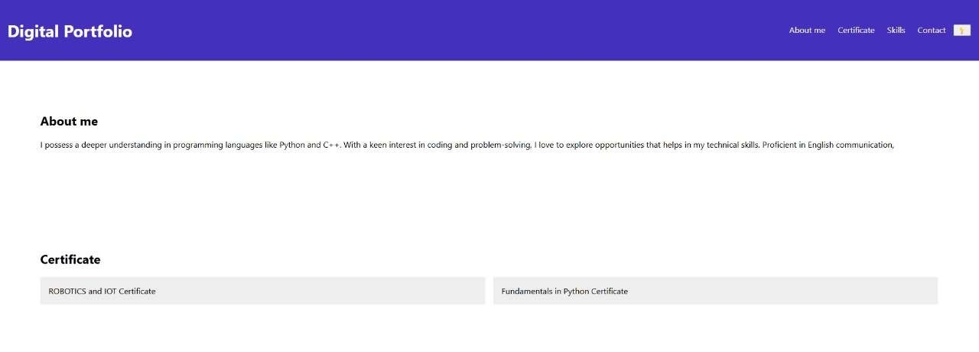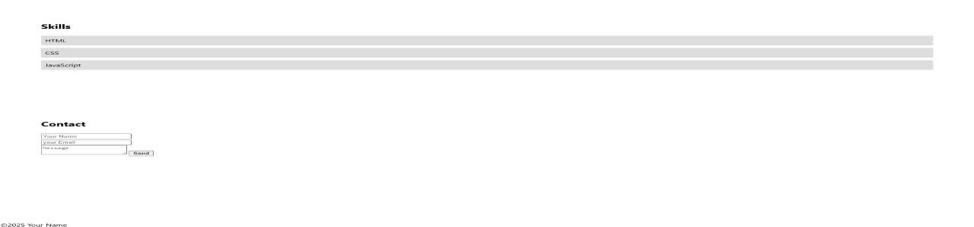

3

/

21/202

4

**A**

**nnu**

**al**

**R**

**e**

**v**

**i**

**e**

**w**



**RESULTS AND SCREENSHOTS:**

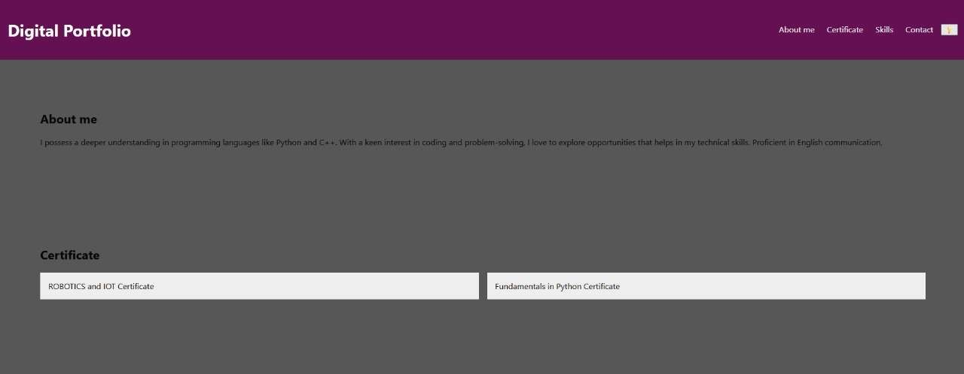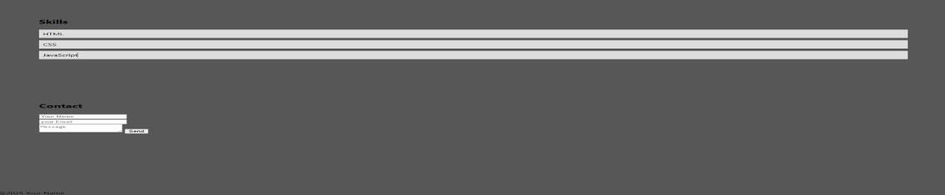

# CONCLUSION

It will help you to develop your personal portfolio easily. It defintely helps the people to introduced them formally to the professionals.